**Assignment 10**

**Feature Branches and Hotfixes**

**Create a 'hotfix' branch to fix an issue in the main code. Merge the 'hotfix' branch into 'main' ensuring that the issue is resolved.**

Step 1: Create & Switch hotfix branch in one command.

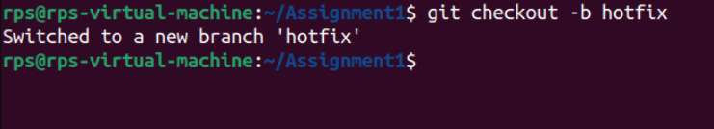

Step 2: Make the commit after do some changes in file.



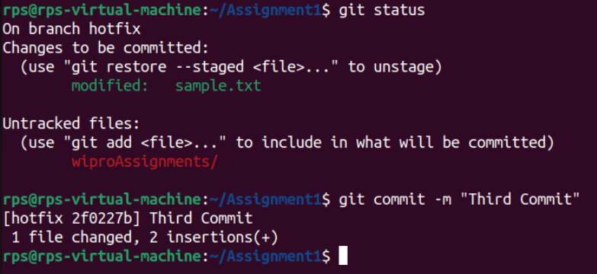

Step 3: Merge the hotfix branch into main branch.

